**AIM:**

To write a C program to multiply two matrices and display the resulting matrix.

**ALGORITHM:**

1. Start.
2. Input the number of rows and columns of the first matrix (r1, c1).
3. Input the number of rows and columns of the second matrix (r2, c2).
4. Check if matrix multiplication is possible: if c1 != r2, print an error and exit.
5. Input the elements of the first matrix (mat1).
6. Input the elements of the second matrix (mat2).
7. Initialize the result matrix (result) with zeros.
8. Use nested loops to multiply the matrices:

For each row i of mat1 and each column j of mat2:

Multiply and sum the corresponding elements:  
 result[i][j] += mat1[i][k] * mat2[k][j]

1. Display the result matrix.
2. End.

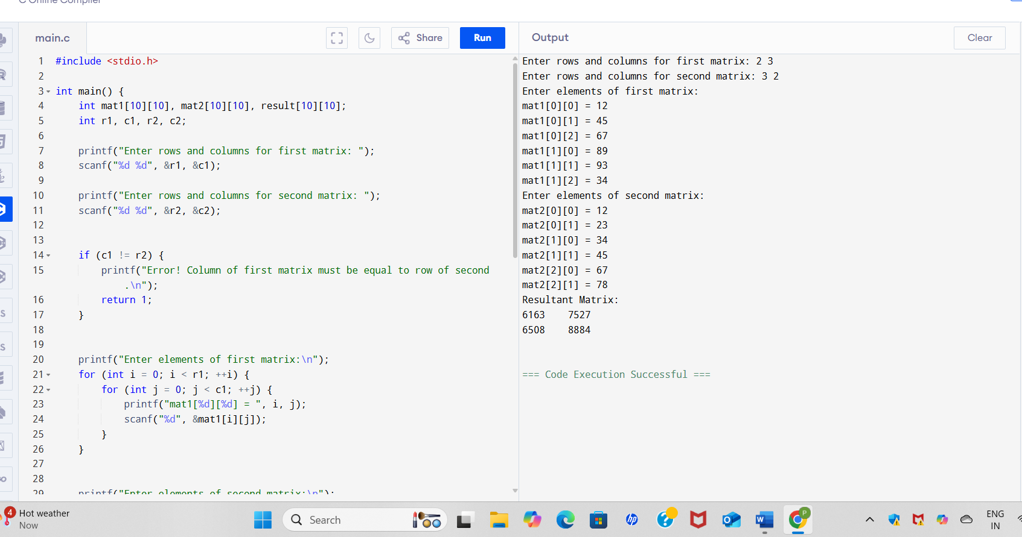

CODE OUTPUT-

Enter rows and columns for first matrix: 2 3

Enter rows and columns for second matrix: 3 2

Enter elements of first matrix:

mat1[0][0] = 1

mat1[0][1] = 2

mat1[0][2] = 3

mat1[1][0] = 4

mat1[1][1] = 5

mat1[1][2] = 6

Enter elements of second matrix:

mat2[0][0] = 7

mat2[0][1] = 8

mat2[1][0] = 9

mat2[1][1] = 10

mat2[2][0] = 11

mat2[2][1] = 12

Resultant Matrix:

58 64

139 154